GROUP 2 - PIM
Writtein By JEssica Fealy
PIM – USER GUIDE

Setting up

LESPI
Before any user can log into the system they are first required to read and agree to all terms and conditions that have been highlighted and detailed within the LESPI. Refusal to agree to these terms and conditions will result in an inability to log into the system.
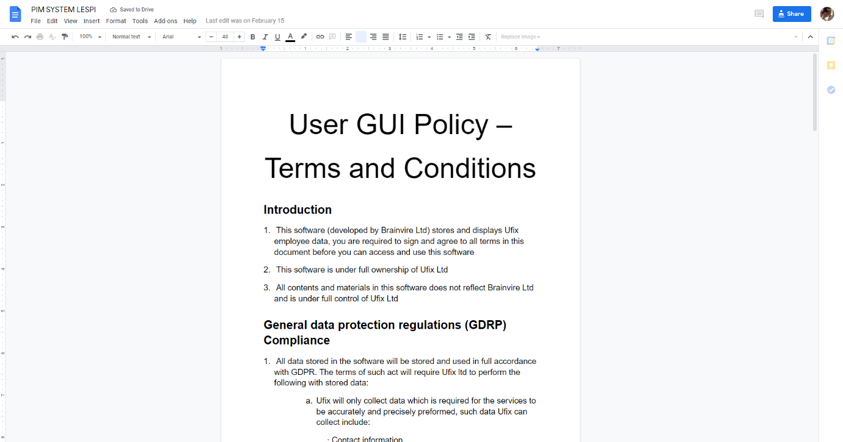

Logging in
This PIM system recognises 2 category of login personal, Admins and general Users. With Admin personal having access to restricted systems such as deleting and creating a user. Each employee is given unique log in credentials, when these credentials are entered, they will be given access to the relevant PIM systems. If incorrect login details are provided, then no access will be given.
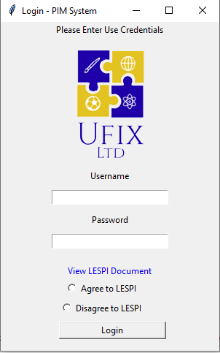

System Logs
All activity taken place within the PIM system is documented into a log file. This file provides an accurate history of all activity. The logs will track events taken place such as, personal logging in, acceptance of LESPI, adding and removing employees from the records.
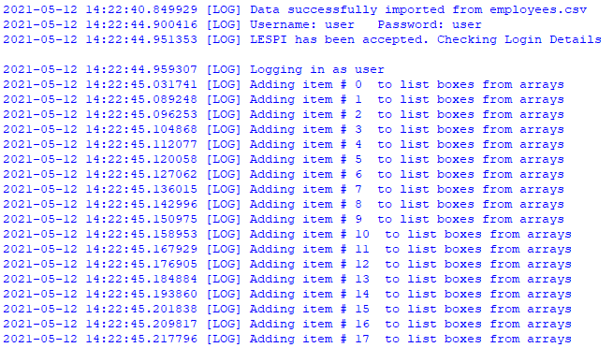

Storing information
All employee information is stored within a standard CSV file. This file is translated into a form in which the system can understand and all employee is inserted into the relevant field upon user login initialisation.
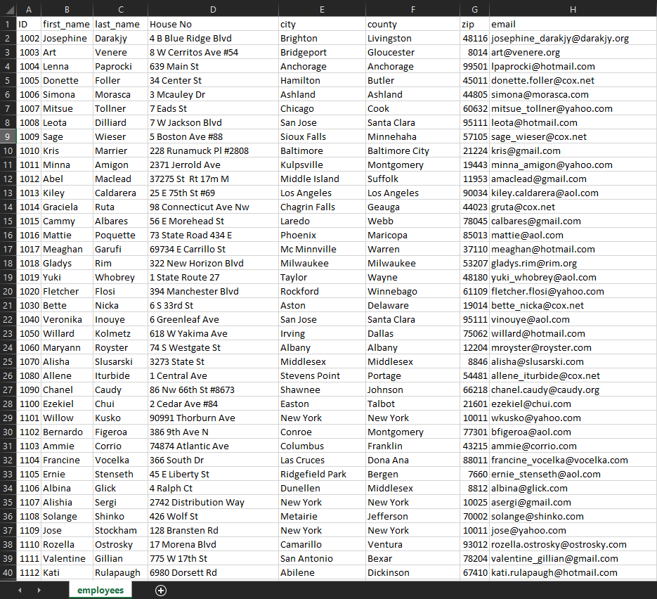
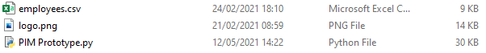

User view
A standard employee is granted very few controls when accessing the system, they are restricted to only view employee data. 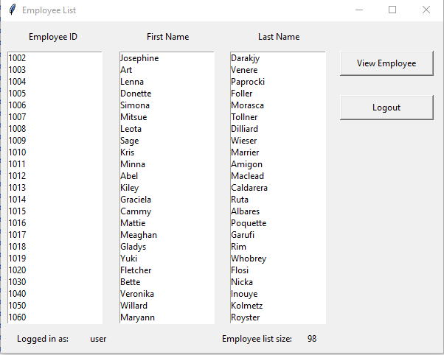
Upon clicking an employee and the “ View Employee “ tab the user will be presented with a pop up detailing all the information for that relevant employee.
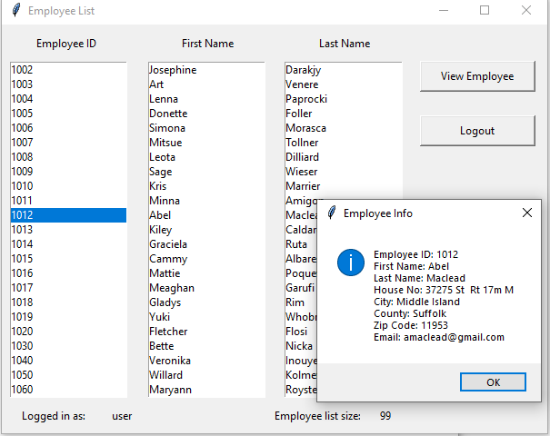

Admin view
An admin is granted with a series of additional privileges and actions than a standard user. An Admin can delete, clear, and create additional users, as well as viewing current employee data.
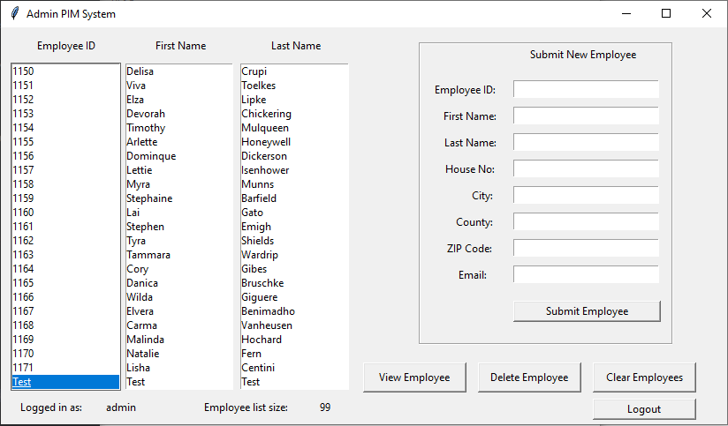

View Employee
Similarly to what happens when a normal employee access the PIM system the Admin user can view any employee records by clicking on the employee ID and pressing the “ View Employee “, when this happens a popup is presented with the relevant employee information.
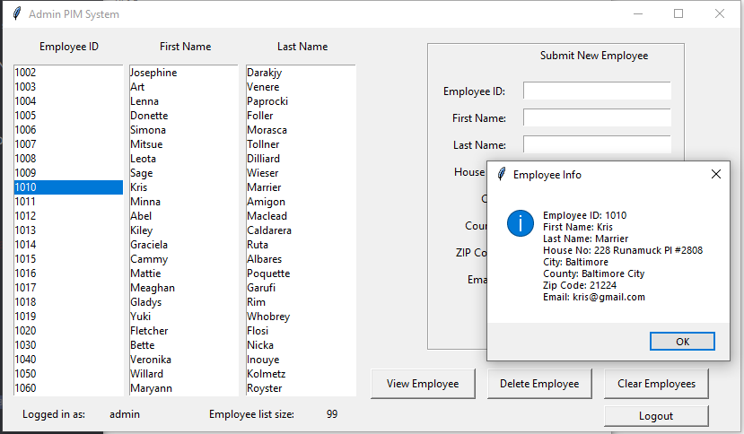

Delete employee
For an admin to delete a employee they select the employee number from the relevant box and press “ Delete Employee “, a pop up is given for the admin to confirm the deletion; once confirmed the relevant employee is removed from the list box, this change is processed in the CVS file by saving the entire employee list back to the CVS file.

Create employee
An additional privilege which an admin has is to add / create new employees on the PIM system. For a new employee to be added unto the system an admin is required to input the necessary employee data into the “ Submit New Employee “ grid, when all needed data is entered and the “ Submit Employee “ button is pressed a popup will be given with the new employee details, if confirmed this data is then added to the employee list.
When the new details have been added to the employee list an update is given to the employee CVS file, this happens to ensure continuity and preservation of data.

